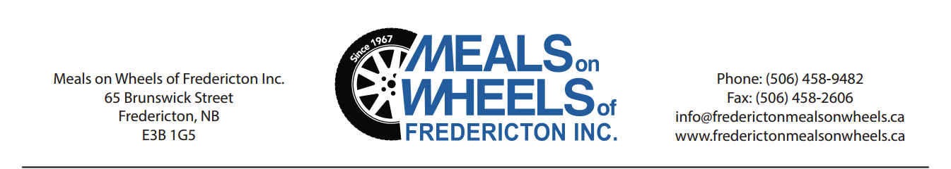
Welcome, New Volunteer!
Meals on Wheels of Fredericton Inc.
880 Hanwell Road, Unit 301-B
Fredericton, NB
E3B 6A3
We wish to thank you for completing an application to become a volunteer with our organization. As a not-for-profit organization, Meals on Wheels relies on volunteers in order to offer our services to the community. We work with seniors, disabled individuals, and those recovering from illness, surgery or injury. Thanks to you, we can provide these individuals with nutritious meals which will enable them to remain healthy and independent in their homes.
The home delivery service was first made available in Fredericton in 1967. Deliveries are made 365 days of the year within the city limits, in New Maryland and Hanwell. We purchase meals from the hospital (DECRH) and York Care Centre. We also host Wheels to Meals; a senior’s luncheon every Tuesday from September until May. The program aims to enhance health and independence by helping senior’s combat isolation and loneliness. A freshly prepared meal is served, local volunteer performers entertain after the meal. Volunteers prepare the hall, serve the meal, and clean up as well as provide transportation for some of the participants.

Without volunteer involvement our organization would not exist. Individuals can participate as members of our Board of Directors, members of committees, delivering meals on a flexible schedule, serving with the Wheels to Meals program, promoting the services through word of mouth, or by providing office support. Our office hours are Monday – Friday, 8:30am - 4:30pm except on occasions when the staff are out taking care of our programs. Since we deliver meals 365 days of the year, a staff member or volunteer will be on call on weekends and holidays when the office is closed. Our voicemail is always on and the person on call checks for messages.
We are a member of the United Way Agency. We are eligible to apply for grants to support our services (Meals on Wheels and Wheels to Meals). We also receive any amount that has been specifically designated by United Way donors for our organization. Without financial support from the community we would not be able to offer meals at a rate that would be affordable to many of our clients. Individuals and businesses can contribute by making cash donations, organizing fundraising events on our behalf such as casual days, bake/yard sales, making in-kind donations (products and services), and supporting our fundraising events. Donors are entitled to a tax-deductible receipt.

We require a criminal record check be performed, and as soon as you have completed your check with the Police or RCMP, please contact us so that we can get you started volunteering. Please note you will have to call to see if your check has been completed. All personal information collected is strictly confidential and will not be released to a third party without your consent. A copy of our Privacy Policy is available. Volunteers who deliver meals or who transport participants to the Wheels to Meals program are entitled to a tax-deductible receipt for the mileage they incur in carrying out their duties.

Many thanks for your generosity. Giving of yourself, your time and your energy to help another is an honorable thing to do. We salute you.
Betty Daniels
Executive Director
Volunteer Driver Job Description
Meals on Wheels of Fredericton Inc.
880 Hanwell Road, Unit 301-B
Fredericton, NB
E3B 6A3
Objectives:
1. To deliver hot, nutritious meals to clients.
2. To provide a friendly social contact.
3. To provide feedback to the Coordinator of Meals on Wheels about the client; that is, if the client does not answer the door or if the client does not seem to be well.

Activities:
1. Pick up meals at 10:45am at the appropriate depot. Check bags to ensure the appropriate number of items are included. Check Route Sheet to ensure that the meals in the bag are for the proper route.
2. Follow the order of delivery according to the Route Sheet. Follow the delivery instructions for each client on the route.
3. Ensure that each client receives the items they have selected according to the menu taped to the top of the hot meal with their name.
4. Ensure that the delivery is carried out as effectively as possible to ensure that the last meal is as hot as possible.
5. Return the insulated bags, the route sheet, and any containers back to the depot.

Performance Requirements:
- A clear criminal record check performed by the Police or RCMP
- A clear Social Development background check
- Reliable transportation, a valid driver’s license, and a minimum of $1M in liability insurance
- Interest in and commitment to providing a friendly and effective service to the clients of the service
- Willingness to promote the organization, the services available, and other volunteer opportunities with the organization

Commitment required for drivers:
- You may deliver meals once a month on a regular basis; when called upon, allowing for your availability, or whenever you know you are available

Accountability:
- Meals on Wheels drivers report to Debbie Carpenter, Coordinator of the program. If you have concerns about the welfare of a client, do not hesitate to contact us!

Friendly Face:
- Besides ensuring good nutrition by delivering balanced meals, you are providing much needed human contact for many of our clients. Please remember to smile and be friendly and supportive.
“Volunteers improve the lives of others while enhancing their own”.

Debbie Carpenter
Volunteer Coordinator
Meals on Wheels of Fredericton Inc.
880 Hanwell Road, Unit 301-B
Fredericton, NB
E3B 6A3

MILEAGE CLAIM FORM

Calculating your Mileage:
The mileage rate for 2018 was .50 cents per kilometer. As per your mileage log, calculate the # of kilometers that you have accumulated delivering meals, transporting participants, or attending meetings during the calendar year.
- Multiply the number of kilometers by .50 cents per kilometer
- Example: If you drove 1473 kilometers during the year.
  - 1473 km x .50 cents = 736.50
  - Round the number off to the nearest dollar
  - Example: $737.00
Write a cheque for the amount you have calculated and make it payable to Meals on Wheels of Fredericton Inc. We will issue a cheque and a tax receipt to you for the same amount. Please deposit it as soon as possible for cash flow purposes. Your cheque to us will be deposited within one week of being received. Return your log and cheque to a staff member or email your log to bbrown@frederictonmealsonwheels.ca.

I have driven kilometers for Meals on Wheels of Fredericton Inc.

In 2018 @ $.50 cents per kilometer* = $ .
I am making a Donation in Kind in the amount of $_________________________

for the following services _____________________________________________
(Please round off to the nearest dollar on both instances above)
*The mileage rate is determined yearly by the Board of Directors.
NAME:___________________________________________________________

ADDRESS:________________________________________________________

CITY: _________________________________POSTAL CODE: _____________

SIGNATURE:______________________________________________________

__________________________________________________________________
For Office Use Only:

Volunteer’s Cheque: Date ____________ $_____________ # _________ Receipt # ________
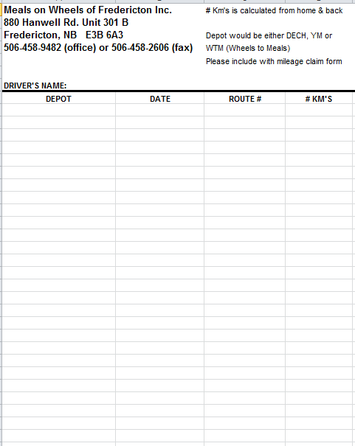

Meals on Wheels of Fredericton Inc.

Volunteer Application

Name: Phone #:

Address:
Postal Code

E-Mail: Occupation:

Workplace: Cell #:

Date of Birth: Work #:
Year / Month / Day

Previous volunteering experience (please indicate name of organization, position held, and duration):

Please indicate your choice of volunteer position:

MOW Driver: Northside: Southside: Regular: Spare: Day(s) available:
WTM (Tuesdays) Driver: Northside: Southside: Hall Volunteer: How often?

Office Support: How often? Day(s) available: Event Volunteer:

Member of Board of Directors or a committee:

For our records only we need to have a photocopy of the following:

Your Driver’s License #: Your Insurance Card:

Contact Person (for emergency purposes):

Name: Daytime Phone #:

Relationship: Date:

Privacy Policy: The information collected is strictly confidential and will not be released to a third party without your consent. A copy of the entire Privacy Policy is available.
How did you hear about Meals on Wheels?:_______________________________________________________
____________________________________________________________________________________________
For Office Use Only: PC: PCC: Orientation: Start Date:
Depot(s): Route(s): Reg: Sub: Weekday: Weekend :
MOWS: Copy to Debbie:

Meals on Wheels of Fredericton Inc.
Volunteer Code of Conduct

Meals on Wheels of Fredericton Inc. is committed to providing volunteers with:

- A positive and productive work environment characterized by respect for the individual.

- Clear information about the requirements and responsibilities of every volunteer position.

- Proper orientation and support to every volunteer.

- Formal and informal opportunities for volunteers to provide feedback, express concerns, and request support.

As a volunteer, I :
Please print name

Am willing to undergo the required screening procedures.
Take on specific responsibilities and expect to be punctual and accountable.

Accept guidance and support from staff member responsible for the program or aspect of the organization for which I volunteer.

Follow policies and procedures required of my position as outlined in the Volunteer Job Description.

Maintain a positive attitude and report all concerns to the appropriate staff person.

Maintain an attitude of open-mindedness and a willingness to attend training sessions to improve the performance of my tasks.

Maintain a relaxed and cheerful attitude. Because effective person-to-person contact is central to my duties, I take the time to address each client and I greet every client with a smile.

Am time-responsible. I arrive on time, perform my duties in a timely fashion, and take the time to finish tasks completely.

Will give as much notice as possible of my absence or resignation from the volunteer position.

I agree to not disclose any information about the clients of Meals on Wheels of Fredericton Inc. that I may acquire while performing my duties.

I agree to report to the staff of Meals on Wheels of Fredericton Inc. anything that is out of the ordinary concerning the clients while performing my duties.

________________________________ __________________________________________
Signature Date

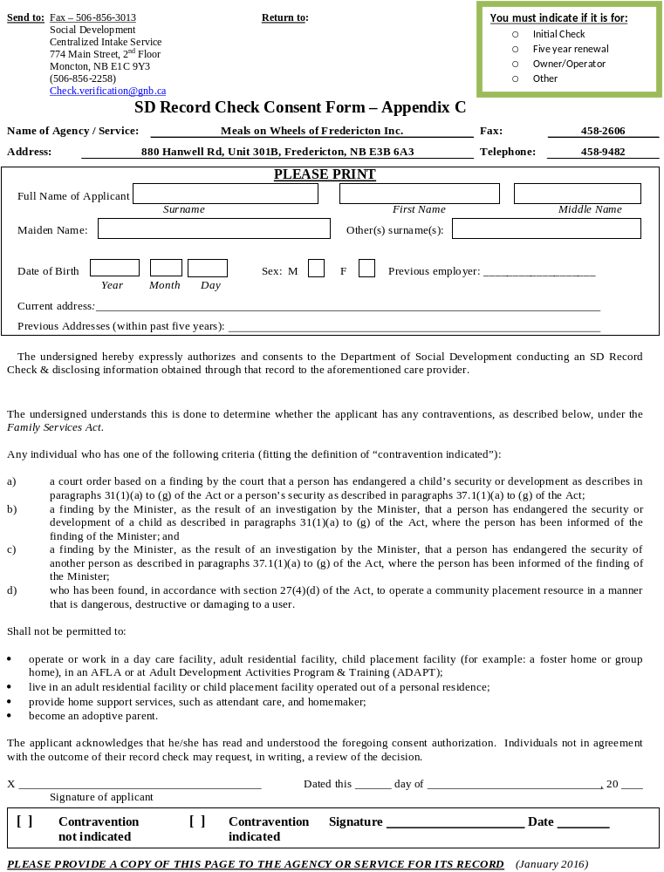



Meals on Wheels of Fredericton Inc.
880 Hanwell Rd. Unit 301 B, E3B 6A3
Tel: (506) 458-9482
Fax: (506) 458-2606
info@frederictonmealsonwheels.ca
www.frederictonmealsonwheels.ca




